PRESS RELEASE
MOrganisation set to play their new single ‘On a Plane’ UNDER a plane!
Acoustic pop group MOrganisation will be playing their new single release ‘ON A PLANE’ beneath a retired nuclear bomber at Wellesbourne Airport, near Stratford-on-Avon on Saturday 26 November. The aircraft is a Vulcan bomber and the group MOrganisation, led by ex-ELO guitarist Dave Scott-Morgan (who is also a Flight Instructor at Wellesbourne), are playing a special concert for members of the plane’s support team (known as 655MaPS). The stage will be directly under the open bomb bay!
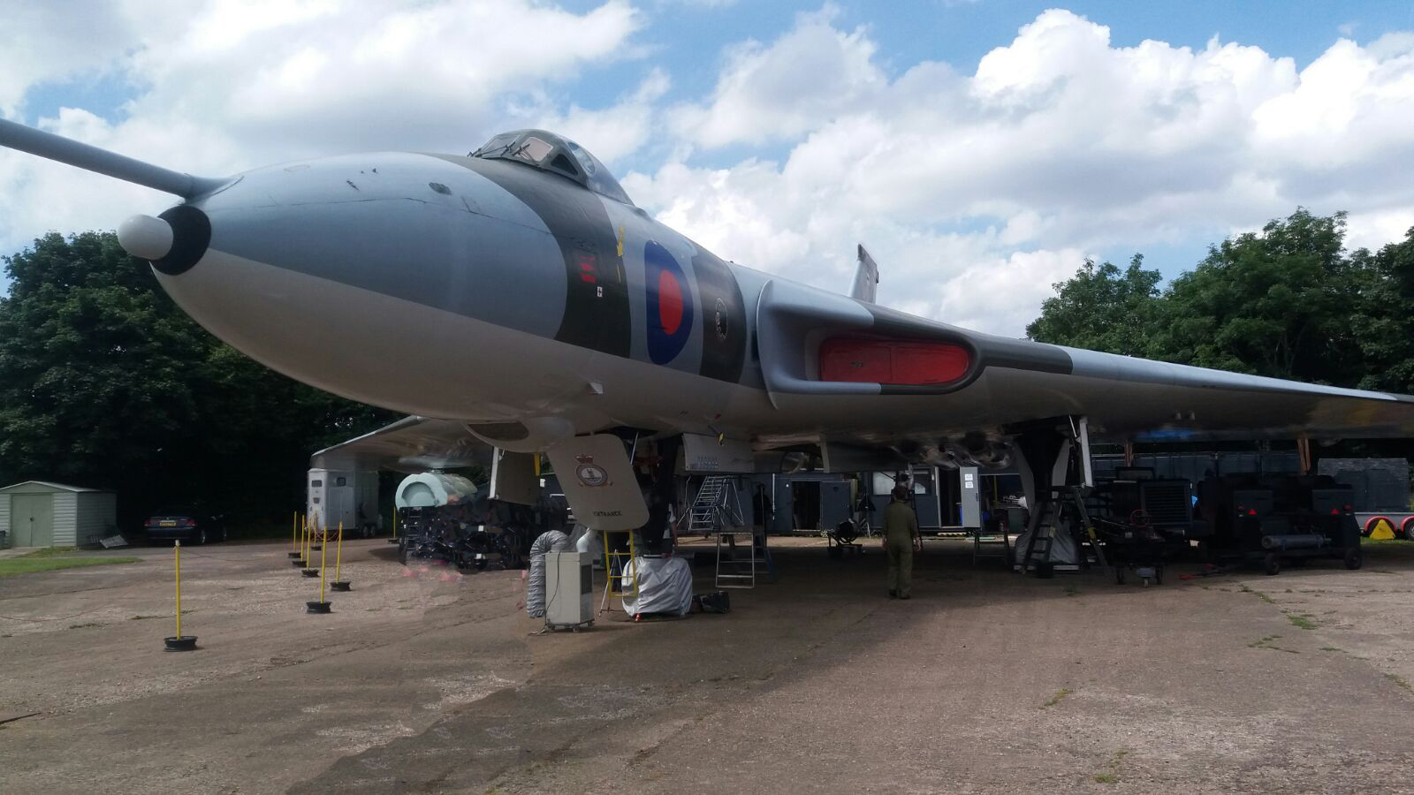
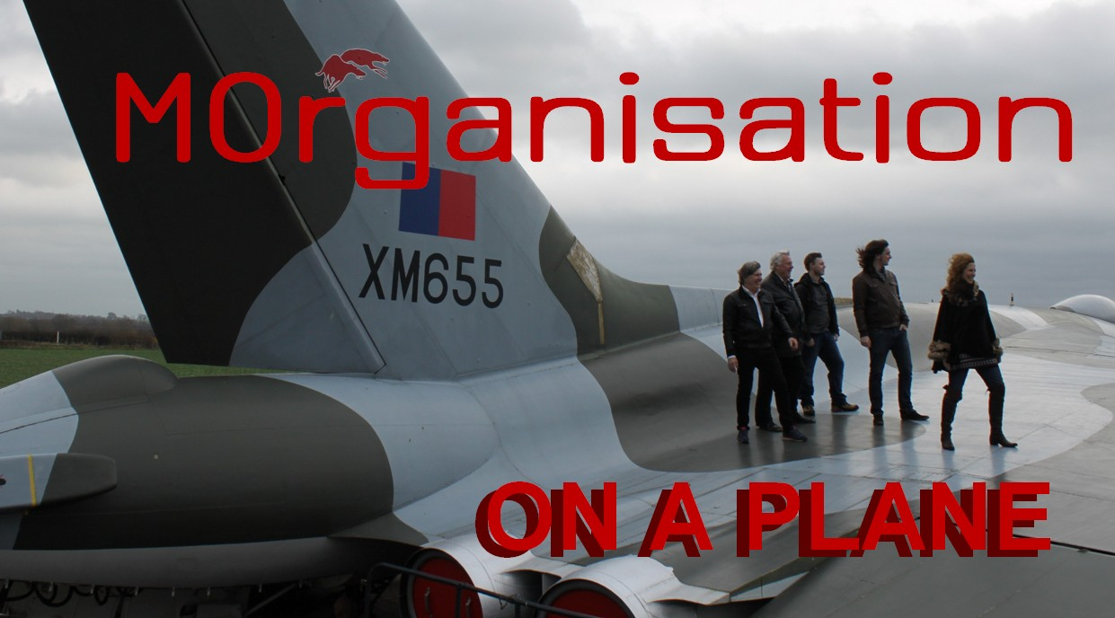
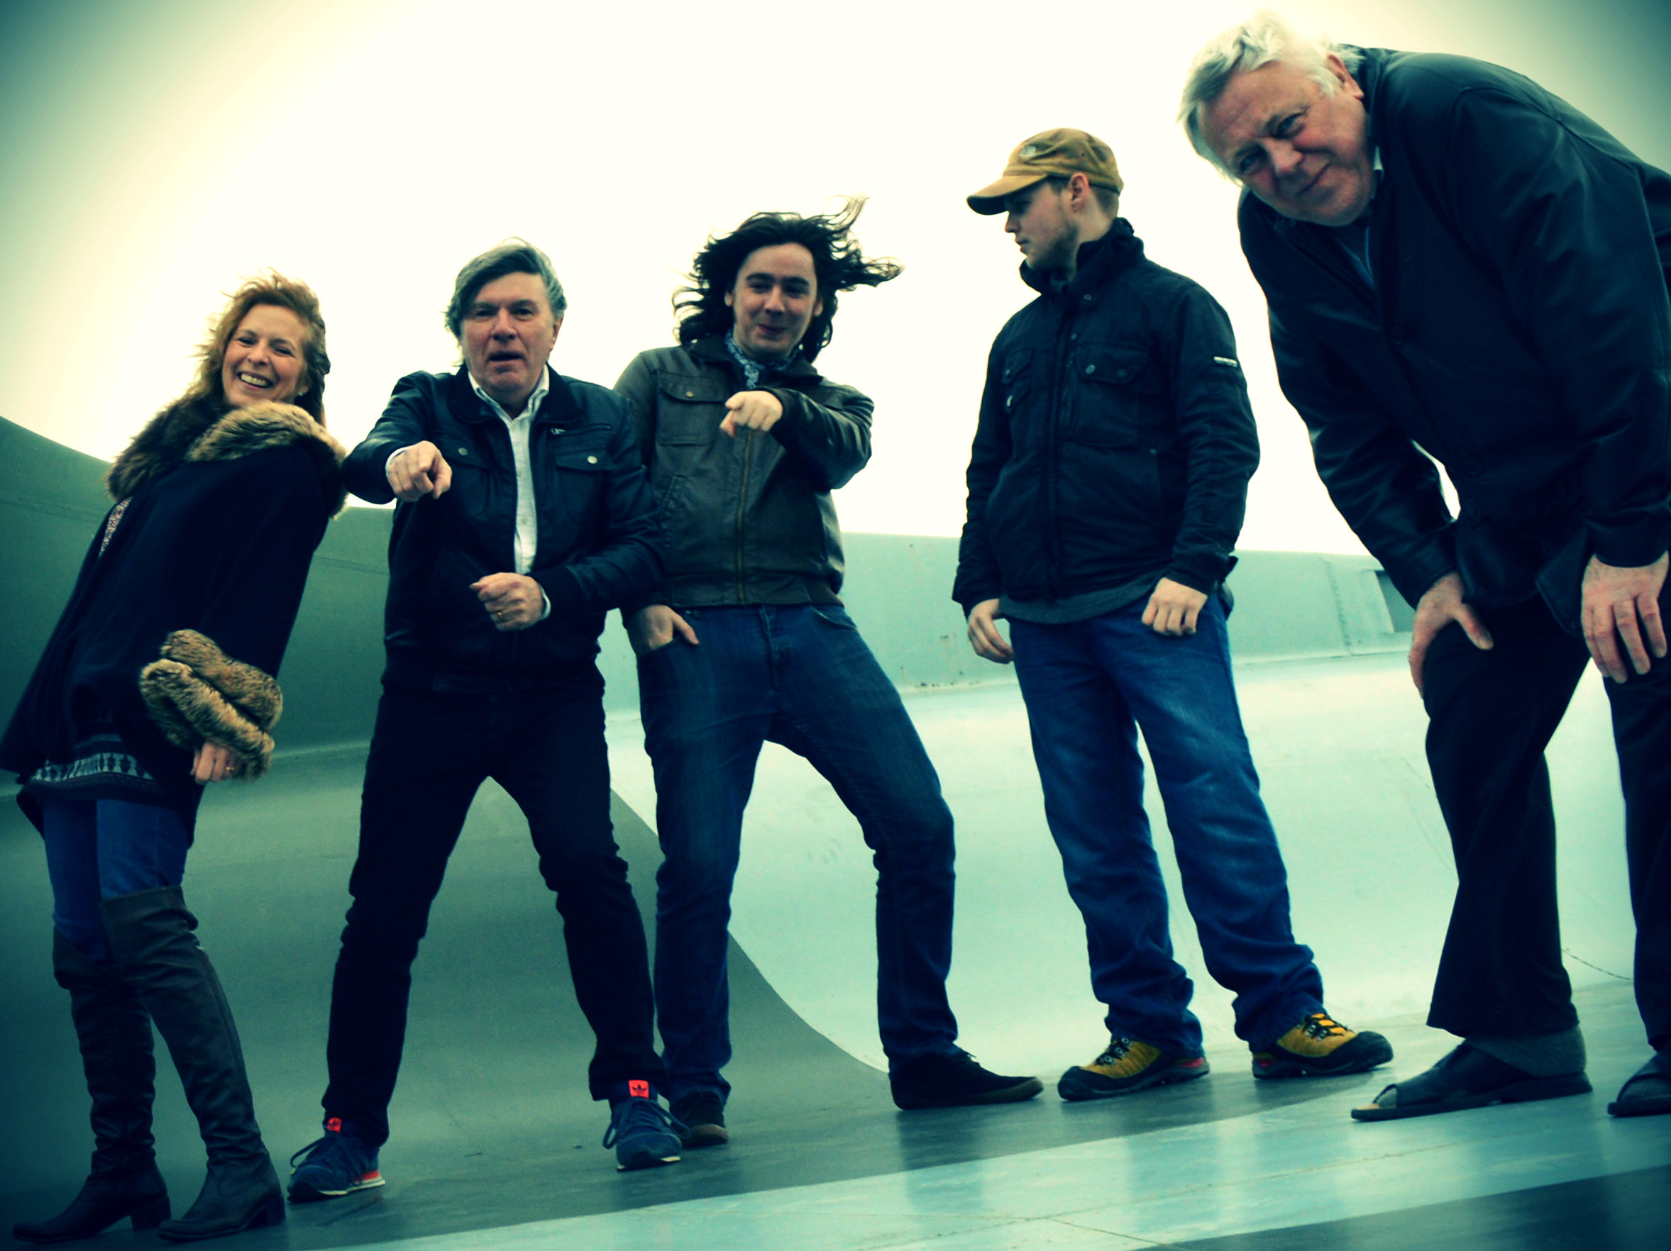
More info: http://www.morganisation.co.uk
info@morganisation.co.uk 07791 466201
The delta-winged Vulcan is one of the most iconic aircraft ever flown. The precursor of Concorde, it was part of the UK's nuclear deterrent force throughout the 60s and 70s. XM655 is the third from last Vulcan to be made. Delivered to the RAF in 1964, it has been at Wellesbourne since 1984 and is one of the few remaining in ground running condition and the only one with uprated Olympus 301 engines. A Fast Taxi is carried out every summer to show off the aircraft and raise funds to support its preservation.

Above: Vulcan XM655 at Wellesbourne
Right and below: MOrganisation

Check out the song! Scan the code →
‘ON A PLANE’ is
the second track.

